
Module 2: Recovery and Wellness – Participant Handbook

Module 2 Additional Resources (optional reading) 2
MHCC’s Guidelines for Recovery-Oriented Practice (June 2015) 2
Wellness Recovery Action Plan: 2
Information from Module 2 Slides 3
Homework to complete before Module 3 5
Video: Al Strong’s History of Peer Support 5
Activity: Submit Recovery Response and Recovery/Wellness definition 5

Module 2 Additional Resources (optional reading)

MHCC’s Guidelines for Recovery-Oriented Practice (June 2015)
https://www.mentalhealthcommission.ca/sites/default/files/MHCC_RecoveryGuidelines_ENG_0.pdf
This is a substantial document (98p.) that is broken up into six chapters which correspond to six values:
- Creating a Culture and Language of Hope
- Recovery is Personal
- Recovery Occurs in the Context of One’s Life
- Responding to the Diverse Needs of Everyone Living in Canada
- Working with First Nations, Inuit and Metis
- Recovery is About Transforming Services and Cultures

Wellness Recovery Action Plan:
This is a self-designed prevention and wellness tool that you can use to get well, and stay well.
https://mentalhealthrecovery.com/
Video about WRAP: https://www.youtube.com/watch?v=pMohYei4Qjo

Information from Module 2 Slides
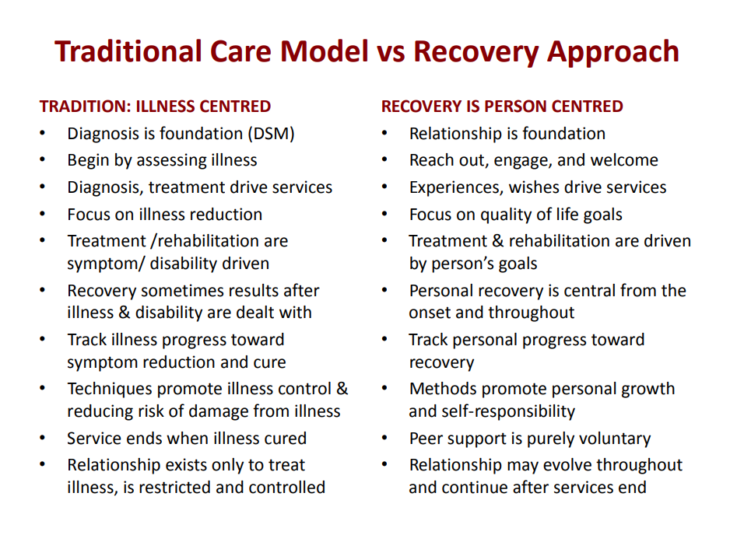Table from Deb Sherman and Allan Strong’s presentation, “Integrating Peer Support with Integrity”(2017)
https://www.peerworks.ca/de/cache/modules_listing/280/rs_recovery-webinar-jan2017-eng.pdf

Seven Dimensions of Wellness
Spiritual: refers to our interest in the nature of human existence, and our awareness of our own principles and values.
Emotional: refers to our mental wellbeing. This includes being aware of the range of feelings we experience and expressing those emotions in a healthy way. However, it does not mean that we have to be positive or feel happy all of the time.
Environmental: refers to our sense of comfort in our physical surroundings and our contributions to protecting the environment.
Physical: refers to the care of our physical bodies. This includes everything from eating nutritious food to engaging in physical activity and having a consistent sleep schedule.
Social/cultural: refers to our willingness to create healthy, productive relationships and get involved in our communities.
Occupational: refers to our engagement in pursuits that provide us some form of personal satisfaction. This can be through work, volunteering, learning, or personal projects.
Financial: refers to our feelings of security or satisfaction concerning our finances.

Homework to complete before Module 3

This homework should be completed before Module 3. It should take approximately 50 minutes.
- Video: Al Strong’s History of Peer Support (48 min 27 sec)
- Submit recovery response
- Submit your definition of Recovery/Wellness

Video: Al Strong’s History of Peer Support
https://vimeo.com/488324439
Former OPDI/PeerWorks board member, Al Strong’s webinar on the history of peer support, entitled “What A Long Strange Trip It’s Been.”
Watch the video and take any notes that you require. We will be discussing the video at the beginning of the module.

Activity: Submit Recovery Response and Recovery/Wellness definition
Answer the following question (that you worked on during the breakout room activity):
“What has supported you in doing the ‘hard work’ of Recovery, of rising to the challenge of recovering your mental health and well-being? What are the elements, ingredients and/or factors that have/continue to support your Recovery?”
Also, reflect on what you’ve read and learned in this module and compile your own definition of Recovery/Wellness. It doesn’t have to be formal. Consider what recovery means to you and how you would articulate that to a peer.
Please e-mail your response to Zebina at zebina@peerworks.ca with the subject line “Your Name Recovery.” e.g. “Allyson Recovery.”
You can send your definition in the body of the email or attach your definition as a Word document and name it “Your Name Recovery.” E.g. “Allyson Recovery.doc”

